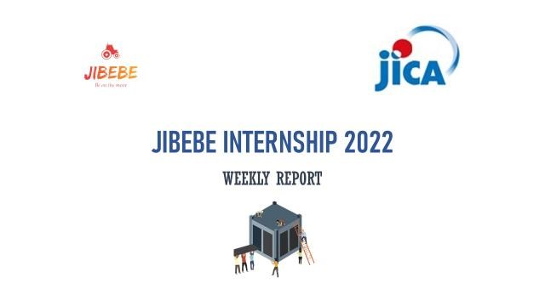

Internship 2022 Progress report

Name: Cynthia Kemboi

# Tasks completed last week

* [#71] Tillage and automation.

Development of guidance systems and autonomous vehicles is current state-of-the-art in agricultural mechanization. Since the late nineteenth century, farmers have been devising methods of making a tractor follow a plough furrow by using a feeler. In the later part of the twentieth century, the combination of hydraulics and electronics allowed for more sophisticated guidance strategies. These strategies include low force feelers that can guide the tractor or implement based on the position or rows, and guiding the tractor based on the position of the vehicle from the Global Positioning System (GPS).

Using a guidance system for agricultural machinery is not a new concept. One of the earliest guidance systems used a wheel to steer a steam-powered traction engine along a plow furrow. A small steel wheel was designed to run in a plow furrow next to the tractor. The guidance wheel was attached to the front wheels of the tractor and held up against the furrow using a spring. As the tractor veered left or right, the guidance wheel in the furrow would steer the tractor in the opposite direction, keeping it on track parallel to the plow furrow.

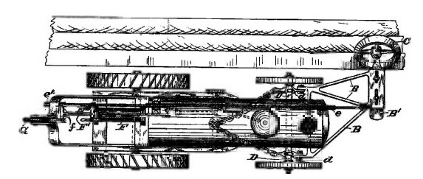

*Figure showing an early furrow following guidance system*

Depending on the situation, different guidance strategies or groups of guidance strategies may be needed to achieve the best outcome. Each strategy uses or combines various technologies to guide the vehicle. For example, consider a tractor cultivating a row crop, such as cotton. A sensor with feelers can locate the row accurately, and ensure that the vehicle follows the row. However, there is no assurance that the tractor is cultivating the correct set of rows. The GPS system can locate the tractor on the proper set of rows, but the accuracy may not be precise enough to cultivate between the rows without damaging the crop. The two systems may be combined to provide a better solution. The ECU can use the GPS portion of the guidance system to ensure that the tractor is cultivating the correct set of rows then switch to the feeler guidance system to ensure that the cultivator is accurately operating between the rows, minimizing the damage to the crops.

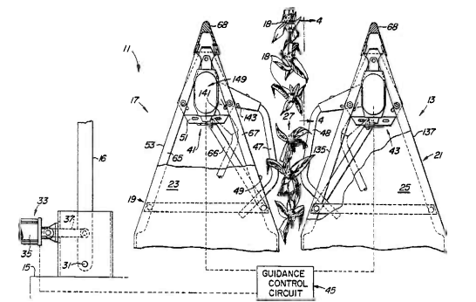

A guidance system that uses crop feelers

There are four guidance strategies:

1. Manual—an operator steers the vehicle based on their observations of the surroundings.
2. Operator assisted—an operator steers the vehicle based on a signal from the guidance system.
3. Semi-autonomous—the guidance system steers the vehicle, but an operator is present to ensure the system is working properly and perform other vehicle functions that are not automated.
4. Fully autonomous—no operator required! The benefits and challenges of each strategy are identified below

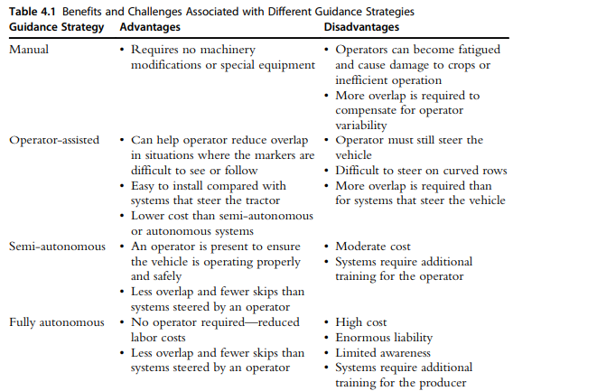

# Tasks in this week

● [#49] Computer vision (vehicle detection, static and dynamic objects )

# Timeline

|  |  |  |
| --- | --- | --- |
| Month | Intern week | Tasks |
| Jan |  |  |
| Week 1 | Identification of parts and drawing of the chassis diagram. |
| Week 2 | Circuit diagram and acquisition of parts. |
| Week 3 | Definition of the path to be followed by the robot car.  Laser cutting of the parts. |

|  |  |  |
| --- | --- | --- |
| Feb | Week 4 | * Assembly of the robot * Ultrasonic program implementation |
| Week 5 | * GPS and compass navigation * Path definition |
| Week 6 | Object identification using computer vision. (Raspberry pi & camera) |
| Week 7 | Transmission of live feed and data from the robot (transmitter and receiver) |
|  | Week 8 | Object dection (static and dynamic) |